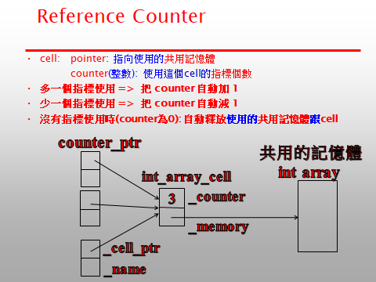

// Due: 5月16日

// 沒依照助教安排的時間完成demo: **作業零分**

/*

/////////////////////////////////////////////////////////

繳交方式

將作業的原始程式檔案以自己學號命名 上傳至 tronclass

如有任何問題請與助教聯絡。

/////////////////////////////////////////////////////////

參考資料: Memory (C++標準庫) 的智慧型指標 shared_ptr

https://zh.wikipedia.org/wiki/Memory_(C%2B%2B%E6%A0%87%E5%87%86%E5%BA%93)

/////////////////////////////////////////////////////////

作業評分要求 :

1. 勿抄襲

2. 完成程式功能

程式除了做規定的計算之外，必須在stdout顯示註解所列的訊息

3. 要徹底清除資料使用的記憶體

4. 詳細清楚的註解解釋程式:

1) 助教老師能看懂

2)

Good Comment (程式碼的目的)

if( record_count > limit) // have all the records been processed?

Bad Comment (程式碼的重覆敘述)

if( record_count > limit) // check if record_count greater than limit

*/



#include <iostream>

using namespace std;

class counter_ptr

{

private:

char * _name;

int_array_cell * _cell_ptr;

};

//template <class T>

class int_array_cell

{

private:

int _counter;

int * _memory;

//T* _memory; //template

};

void main()

{

// PART 一 (35分)

counter_ptr b("b", new int[10]); //需要撰寫 counter_ptr constructor(建構子) 接受兩個參數

// stdout 輸出: int_array_cell is allocated

// stdout 輸出: counter_ptr b is assigned to an int_array_cell: counter 1

{

b = new int[100]; //需要撰寫 counter_ptr operator=

// stdout 輸出: int_array_cell counter 0: deleted

// stdout 輸出: int_array_cell is allocated

// stdout 輸出: counter_ptr b is assigned to an int_array_cell: counter 1

counter_ptr a("a"); //需要撰寫 counter_ptr constructor(建構子) 接受一個參數

// stdout 輸出: counter_ptr a is not assigned to an int_array_cell

a = b; //需要撰寫 counter_ptr operator=

// stdout 輸出: int_array_cell counter is increased: counter 2

// stdout 輸出: counter_ptr a is assigned to an int_array_cell: counter 2

}

// a leaves it scope: //需要撰寫 counter_ptr destructor

// stdout 輸出: counter_ptr a is deleted

// stdout 輸出: int_array_cell counter is decreased: counter 1

// PART 二 (35分)

for(int i=0; i<10; i++)

b[i] = i; //需要撰寫 counter_ptr operator[] 寫值(回傳資料的參考 return type: int &)

for(int i=0; i<10; i++)

cout << b[i] << ' '; //需要撰寫 counter_ptr operator[] 讀值(回傳資料)

cout << endl;

// stdout 輸出: 0 1 2 3 4 5 6 7 8 9

counter_ptr c("c");

// stdout 輸出: counter_ptr c is not assigned to an int_array_cell

c = b;

// stdout 輸出: int_array_cell counter is increased: counter 2

// stdout 輸出: counter_ptr c is assigned to an int_array_cell: counter 2

b.release(); //需要撰寫 counter_ptr release function: 不使用記憶體

// stdout 輸出: int_array_cell counter is decreased: counter 1

// stdout 輸出: counter_ptr b is not assigned to an int_array_cell

}

// c leaves it scope: //需要撰寫 counter_ptr destructor

// stdout 輸出: counter_ptr c is deleted

// stdout 輸出: int_array_cell counter 0: deleted

// stdout 輸出: counter_ptr b is deleted

/*

PART 三 (30分)

1) 用 template 改寫 class counter_ptr int_array_cell

2) 重覆 PART 一 二 的測試

*/